Import Data using Transform Maps (Spreadsheet)
Phase 6: Project Testing Phase

1. Overview
Testing verifies whether the imported employee information is correctly created in ServiceNow. The Employee Test table is checked after transformation, and the values of Employee ID, Employee Name, Email, Department and Location are verified.
Coalesce is tested by importing existing and new employee IDs. Existing records should be updated while new records should be inserted. Repeating the same data is used to verify that duplicate records are not unnecessarily created. The reports are also checked.

2. Key Activities
- Verify successful employee record creation.
- Check all mapped field values.
- Check Transform History.
- Test new employee records.
- Test updates to existing employee records.
- Verify duplicate handling with Coalesce.
- Check department and location reports.
- Check the employee list report.
3. Detailed Process
In this phase, the project work related to **Project Testing Phase** is carried out according to the overall ServiceNow project workflow. The activities are recorded in sequence so that the implementation can be understood and demonstrated clearly.

4. Expected Outcome
The phase should produce a clear and documented output that can be verified before moving to the next phase. The project remains focused on importing spreadsheet employee data into ServiceNow using Import Sets and Transform Maps.

5. Project Evidence / Screenshots
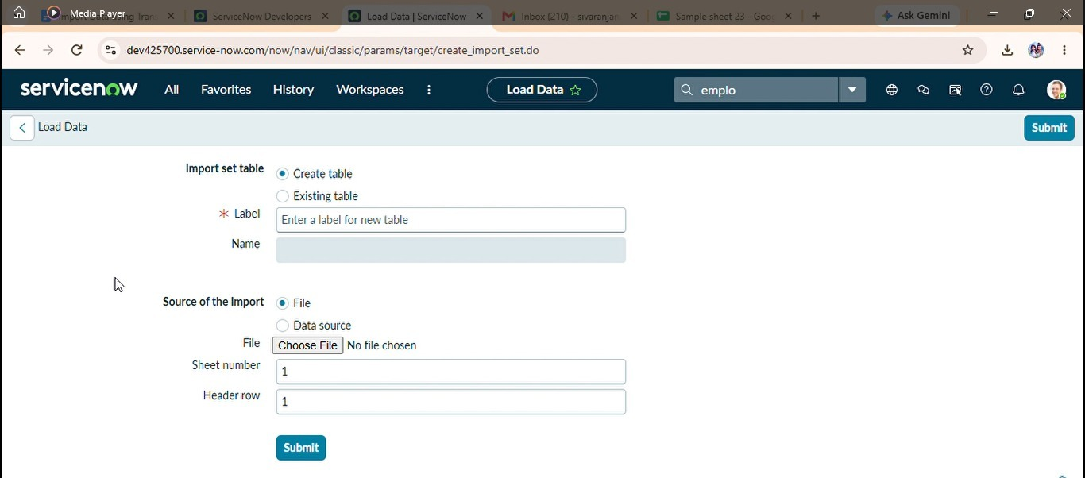

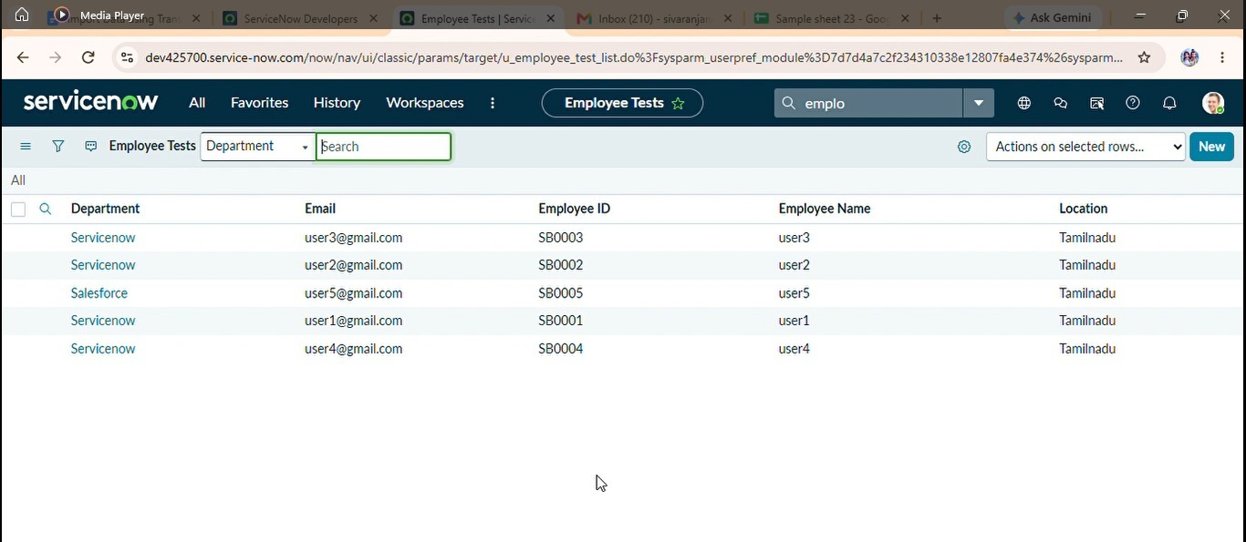

6. Phase Summary
Phase 6 completes the activities required for Project Testing Phase. The documented output and screenshots provide evidence of the project work and support the transition to the next phase.

